Centos
-You should yum install nano onto your centos machine, otherwise use vi
Create a new user: /usr/sbin/adduser username
Create a new Password: passwd username
Adding User’s Privileges
Setup new user with root privileges: /usr/sbin/visudo
Find This – add your new user in the following format
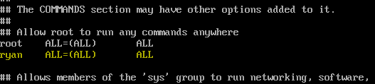
Setting up password-less SSH
First step, generate new keys: ssh-keygen -t rsa -b 4096
Go to the directory: cd ~/.ssh
To copy your pub key to the other machine use: ssh-copy-id -i id_rsa.pub root@address
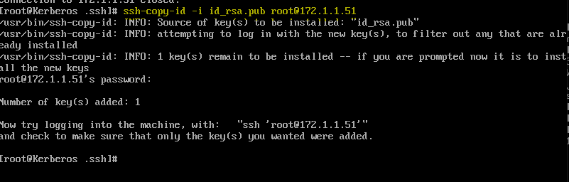
You should now be able to connect remotely.
On the host machine, you can disable root login.

Turning off Root SSH & Allowing User’s to SSH In
Type: nano /etc/ssh/sshd_config
Hit control+^w and type in #PermitRootLogin
Uncomment and change to no
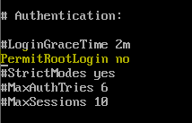
DNS is on by default and you may also want to turn that off.
Lastly, go to the bottom and add the user you created if you want another way to remote in.
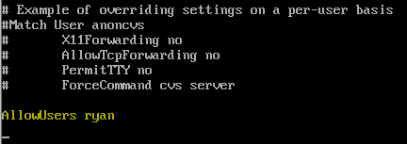
Generating new keys
You should always generate new keys when working from a cloned machine.
(If you want to keep a copy of your old keys move to a new directory before generating new keys.)
To generate new rsa keys: ssh-keygen -t rsa -f /etc/ssh/ssh_host_rsa_key
Recommended use: ssh-keygen -t rsa -b 4096
Changing SSH Default Port
If you change the default SSH port there is more configuration required **coming soon**

Reference Links:
- http://www.servermom.org/basic-centos-setup-before-building-a-working-server/414/

