CENTOS
Getting on the Networking
Adapter configuration files: /etc/sysconfig/network-scripts/
Open adapter in text editor: vi networkInterfaceName
(Another way we can do this is to type the command: nmtui)
Basic Configuration:
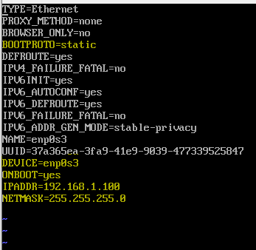
Afterwards, restart the network: systemctl restart network
You can also do: ifdown interfaceName
Ifup interfaceName

Configuring a router
Configuring a router is very straight forward. First make sure you have two network interfaces with the command: ip a
As before, go to the router settings and configure your interfaces
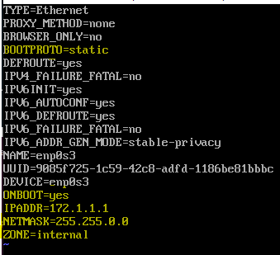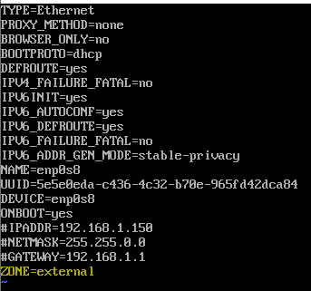
Next, we need to enable ip forwarding as so: vi /etc/sysctl.d/ip_forward.conf
(Sorry for the *typo*, it’s spell forward.conf)
Type this into the file and save.
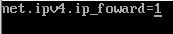
We must configure the firewall with the following command:
firewall-cmd --permanent --direct --passthrough ipv4 -t nat -I POSTROUTING -o <dev name> -j MASQURADE -s 255.255.0.0/16

Next, we must restart the services with the following two commands:
Systemctl restart network
Systemctl restart firewalld
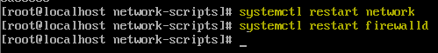
This command will show services running on the external interface
firewall-cmd --list-all --zone=external
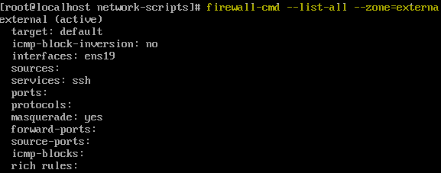
This is how you add port forwarding to something like a webserver.
Firewall-cmd --zone=external --add-forward-port=port=80:proto=tcp:toport=80:toaddr=172.1.1.2
Also try:
firewall-cmd --zone=external --add-forward-port=port=80:proto=tcp:toport=80:toaddr=172.1.1.2 --permanent

