CENTOS
Configure your router to use DHCP
Firstly do: yum -y install dhcp
Configuration files are at: /etc/dhcp/dhcpd.conf
Start by copying the example file over to the configuration file:
cp /user/share/doc/dhcp*/dhcpd.conf.example /etc/dhcp/dhcpd.conf
Next go into the file and first change the heading information: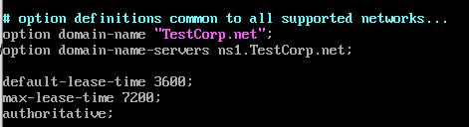
Next, we setup the information our dhcp server is going to be giving out along with its scope.
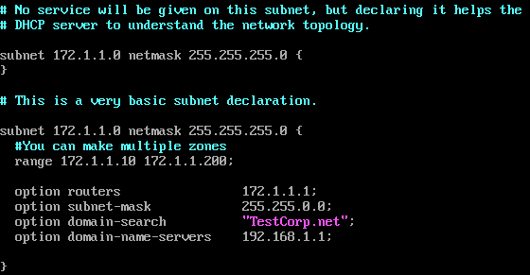
If you need to configure static IP’s do that next. Get the hardware Id from: ip a
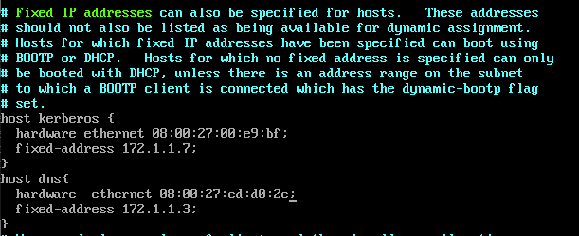
Delete everything else in the file you do not need.
Exit the file and type: systemctl start dhcpd
To start at startup: systemctl enable dchpd
If there any errors use this to help debug: systemctl status dhcpd
To configure firewall to allow it through: firewall-cmd --zone=internal --permanent --add-service =dhcp

