CENTOS
Installations
Things you may want to install.
yum install httpd
yum install php
yum install php-mysql
Restarting service and start on startup command
Reload Apache2 after installation: service httpd restart
To make your webservice start on reboot: chkconfig httpd on
Configuring simple webpage with html
Website pages directory: /var/www/html/
Configuration files: /etc/httpd/conf/httpd.conf
Logs: /etc/log/messages

You can use any text editor (vim has special colors for html): vim /var/www/html/index.html
This will be the default page for our website.
Inside of the file enter the following html to create a page.
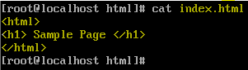
//**To allow http (services) through the firewall**\\
Next, we have to open the firewall to allow http: 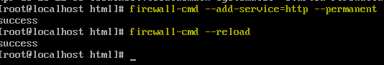
Try to connect to your webserver through a web browser with its IP address!
How to view and remove firewalld services (like SSH…)
To view active rules: firewall-cmd --list-all
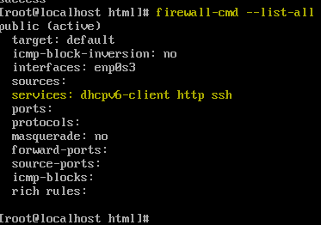
To remove a firewall-cmd rule:
Reload the firewalld: firewall-cmd --reload
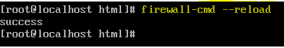
Backup configuration files
To find: cd /etc/httpd/conf
Type Command: cp httpd.conf httpd.conf.original
Command w/ Full Path: cp /etc/httpd/conf/httpd.conf /etc/httpd/conf/httpd.conf.original

Reference Links:
- http://www.servermom.org/how-to-build-working-centos-server-with-apache-and-php/428/
- https://www.youtube.com/watch?v=p90yWh26j94
- https://linuxhint.com/open-port-80-centos7/

